QR CODE GENERATOR
@CREATIVITY THINK (9483175986/7019689991)

ABSTRACT:
The QR Code Generator is a web-based application designed to create dynamic QR codes for various commercial, marketing, and event-based applications. Users can input text or data, generate downloadable QR codes, and manage their previously generated codes through a history dashboard. Administrators monitor QR code usage, manage users, and export analytics for reporting. The system uses Django with the qrcode library and Django Rest Framework on the backend, while React and react-qrcode-logo power the frontend for efficient and visually accurate QR rendering. This project supports rapid, reliable QR creation with analytics, making it suitable for businesses, marketers, and event organizers..

INTRODUCTION OF THE PROJECT:
QR codes have become an essential tool for modern communication, enabling quick access to digital content through mobile scanning. The QR Code Generator project provides a robust platform for creating, downloading, and sharing QR codes integrated with analytics and history tracking. Users can generate QR codes within seconds, while administrators monitor code usage trends and export data for decision-making. Using Django and DRF on the backend with React on the frontend ensures a scalable and responsive system capable of supporting marketing, retail, educational, and event-based use cases. This project enables efficient QR creation and centralized data management..

PROJECT OBJECTIVES:

• Build an efficient platform for generating dynamic QR codes
• Support QR code downloads, sharing, and history tracking
• Provide analytics on generated QR codes for users and admins
• Enable admin-level control for monitoring and managing QR usage
• Implement a scalable and user-friendly web interface
• Ensure reliable backend services for QR code rendering and storage

PROBLEM OF THE STATEMENT:
Businesses and individuals often require quick, customizable QR code creation, but many existing tools lack history tracking, analytics, or administrative control. Manual generation becomes difficult when large numbers of QR codes must be monitored or reused. Additionally, organizations require insights into scan frequency, usage patterns, and user activity. The QR Code Generator addresses these challenges by providing a centralized platform for generating, storing, and analyzing QR codes while allowing administrators to manage users, monitor public QR codes, and export detailed analytic reports for planning and marketing..

MOTIVATION OF THE PROJECT:
• Growing demand for QR codes across marketing, retail, and event sectors
• Need for centralized analytics to track QR usage patterns
• Provide a simple and fast interface for generating and downloading QR codes
• Improve administrative capability over publicly shared QR codes
• Support businesses with reusable and trackable QR assets

BLOCK DAIGRAM OF PROJECT:

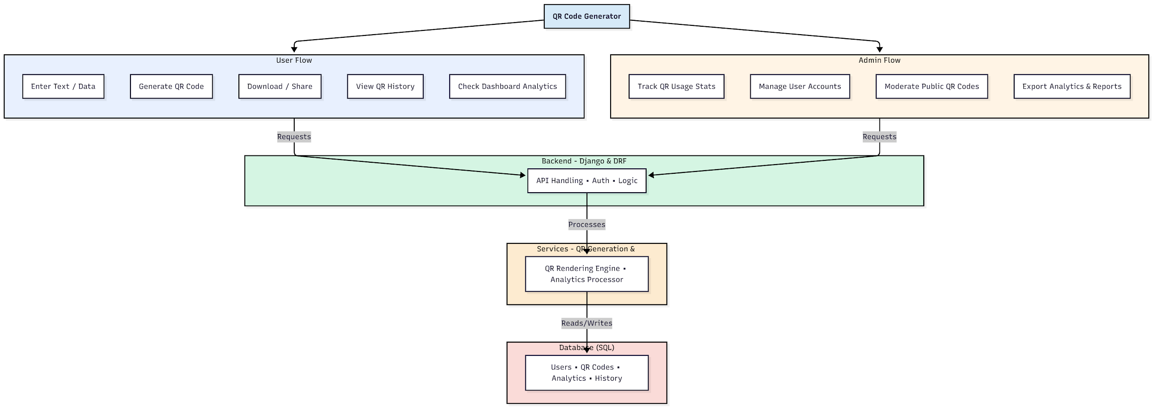

WORKING OF THE PROJECT:
The QR Code Generator operates by accepting user input such as text, links, or encoded data, which the system then processes to generate dynamic QR codes. Users can download or share these QR codes and retrieve previously generated codes through a history panel and analytics dashboard. The backend handles QR rendering through the qrcode library while managing user authentication, storage, and data retrieval through REST API endpoints. Administrators oversee platform activity by tracking QR scans, managing public QR codes, moderating content, exporting analytics, and controlling user access. This integrated workflow ensures efficient QR creation and administrative oversight..

SOFTWARE REQUIREMENT:
- Backend:
  - Python 3.x
  - Django
  - Django REST Framework
  - SQLite/PostgreSQL
- Frontend:
  - Node.js and npm
  - React.js
  - Axios
- Development Tools:
  - Visual Studio Code
  - Postman (for testing APIs)
  - Git/GitHub (for version control)
- Server/Deployment (Optional):
  - Gunicorn, Nginx, or Heroku/AWS for hosting

ADVANTAGES OF THE PROJECT:

• Fast and dynamic QR code generation
• Centralized history and analytics dashboard
• Admin monitoring for public QR usage
• Easy download and sharing options
• Secure backend handling and user authentication
• Useful for marketing, retail, and event workflows
• Customizable and reusable QR assets
• Supports business analytics and strategy planning

APPLICATIONS OF THE PROJECT:
• Retail shops for digital menus and product links
• Marketing agencies for campaign tracking
• Tech events and conferences for digital passes
• Schools or colleges for quick-access resources
• Restaurants for scan-based menus
• Payment gateways for QR-based transactions
• Public information displays
• Startups needing trackable QR campaigns

REFERENCES:

- Django REST Framework Documentation — Django Software Foundation. Django Documentation. Available: https://docs.djangoproject.com/
- Django REST Framework. DRF Documentation. Available: https://www.django-rest-framework.org/
- React. React Official Documentation. Available: https://reactjs.org/docs/getting-started.html
- Redux. Redux Documentation. Available: https://redux.js.org/introduction/getting-started
- PostgreSQL Global Development Group. PostgreSQL Documentation. Available: https://www.postgresql.org/docs/
- MySQL. MySQL Reference Manual. Available: https://dev.mysql.com/doc/
- Git. Git Documentation. Available: https://git-scm.com/doc
- Node.js. Node.js Documentation. Available: https://nodejs.org/en/docs/
- Axios. Axios Documentation. Available: https://axios-http.com/docs/intro
- Socket.io Documentation – https://socket.io/docs/

